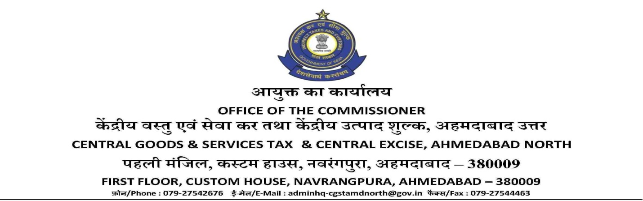
F. No.: I/22-07/2017-18/Adm.-Pt.II Dated: 02.11.2018

INDICATIVE TENDER NOTICE INVITING TENDERS FOR HOUSEKEEPING SERVICES
Sealed Tenders are invited from reputed & experienced contractors based in or around Ahmedabad having valid ISO Certificate to carry out the work regarding cleaning of office premises (excluding expenses on cleaning materials) situated at different locations of Ahmedabad functioning under jurisdiction of Central GST & Central Excise, Ahmedabad North (approximate area of 58,814 sq. ft.) on contract basis only.
This service will be required for a period of one year from the date of entering into contract. Bidders may either download tender documents along with other details / term & conditions from websites: www.cbec.gov.in or may obtain the same from the Administrative section, (Adm./HQ) of Central GST & Central Excise, Ahmedabad North, 1st floor, Custom House, Nr. All India Radio, Navrangpura, Ahmedabad-380009 during office hours. Corrigendum / changes, if any shall be published in the said websites only.
Last date of submission of bids: 23.11.2018 (14.00 hrs.)

Sd/-
(Gyan Chand Jain)
Joint Commissioner (P&V),
Central GST & Central Excise, Ahmedabad North.

